# Music Db

You are working on a team that is building a music database. The team is currently building some REST services. You are responsible for building the REST services to manage the Artist, Album and Song entities. The architect has defined the entities as follows:

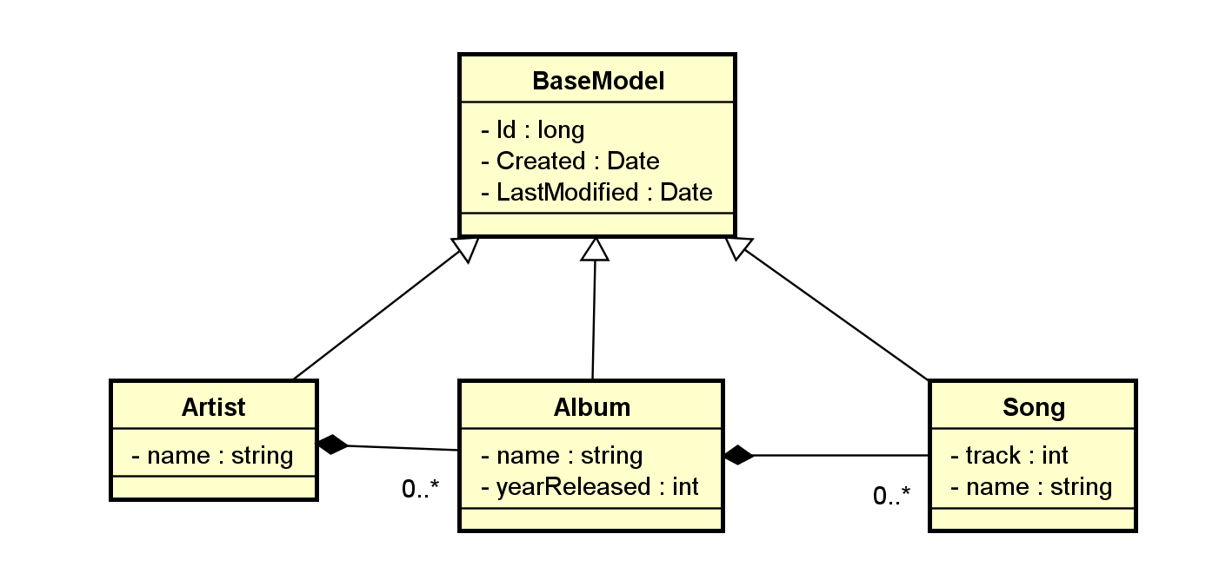

The team has adopted Spring as the framework of choice for all server side development. Further, the architect has mandated the following technical requirements:

* All REST services should use Spring boot to enable self-hosting
* REST services should support all http verbs required for CRUD operations
* Spring configuration should be done via code/annotations not xml
* All models must be marked up with JPA annotations
* The service/repository pattern must be used
* All service and repository code must have 100% unit test coverage
* The database has not been provisioned yet exist so an H2 database can be used for persistence for this phase
* For this phase the database should be seeded with some test data for validation (see the data.sql file in the git repository)
* Maven is the build tool of choice

<https://github.com/validusrecruitment/java-rest>